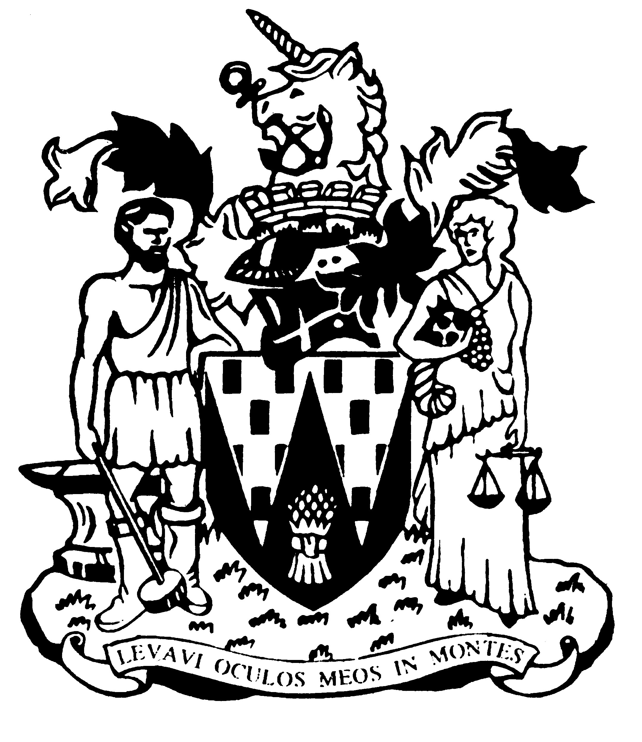

Workington Town Council

Annual Report 2022-23

Councillor Denise Rollo
Mayor of Workington

Workington Town Council
Membership – April 2022-2023
Name | Ward
Cllr Denise Rollo (Town Mayor) | Salterbeck
Cllr Beth Dixon (Deputy Town Mayor) | Northside
Cllr Carole Armstrong | Salterbeck
Cllr R Briggs | Harrington
Cllr Barbara Cannon | Westfield
Cllr David Farrar | St Michaels
Cllr Sue Fryer | St John’s
Clr Deb Garton | Stainburn
Cllr Ged Glaister | St John’s
Cllr Hilary Harrington | Harrington
Cllr Michael Heaslip | St John’s
Cllr Bernadette Jones | St Michael’s
Cllr Jackie Kirkbride | Stainburn
Cllr Paul Larkin | Harrington
Cllr Antony McGuckin | St John’s
Cllr Sean Melton | Westfield
Cllr Billy Miskelly | St Michaels
Cllr Patricia Poole | St John’s
Cllr Denice Rollo | Salterbeck
Cllr Blain Sansom | Moorclose
Cllr Neil Schofield | Westfield
Cllr Paul Scott | St John’s
Cllr Stephen Stoddart | Moorclose
Cllr Linda Williams | Moorclose
Cllr Ellie Wood | Salterbeck
Cllr Will Wilkinson | St Michael’s

Annual Report 2022-23
The financial year 2022-23 saw Workington Town Council add to the council’s portfolio with the purchase of The Ranch. This will allow provision for young people of the town to enjoy the recreational sports facilities.
This year the council has focussed on our commitment to the environment and our continuing collaboration with Workington Nature Partnership. Vulcans Park saw the installation of the Nightingale Garden and Monument and the Reflection Garden as a place where residents can reflect on the challenges over Covid and to remember those we loved and to thank those keyworkers. We have also installed a new play area in the park along with other additions of the Bee Happy Garden, mini tennis nets, and the Love My Hut facelift.
We held our usual annual events; Remembrance Sunday, Armed Forces Day, Easter Trail, Christmas Light switch on, Shakespeare in the Park (odd socks), Fireworks display and many more and to focus on health and wellbeing there was the Festival of Running and the Reach Out Event.
In 2022 we held a Jubilee event in the park where thousands of people attended but sadly later that year we saw the very sad death of the Queen, the Council’s condolences were conveyed to His Majesty King Charles. Early May 23 saw the nation come together again in celebration of the Coronation of King Charles III and a screening in the park was well attended.
Our links with our twin towns of Selm and Val De Reill were forged again after a break due to Covid and we were invited to events in both towns by the mayors. The Mayor of Selm and a group came along to visit Workington to take part in the Coronation celebrations.
A representation was made to the Parliamentary Boundary Commission regarding the upcoming boundary changes in Workington where we insisted that Northside should be kept in the same constituency as Workington.
Cllr Denise Rollo, Mayor

An overview of the Town Council’s Accounts for the year ending 31 March 2023

The council collected £631,450 from council taxpayers in 2022-23.

Additionally it received grant income and funding from a number of sources, which included:
- £1,800 from The National Lottery Community Fund towards the Queen’s Jubilee event
- £2,000 from Allerdale Borough Council towards the Summer Camp events
- £12,246 from the Welcome Back Fund for the town centre planters
- £4,500 from Cumbria County Council towards the Ashfield Road play area
- £126,288 from Allerdale GDF Community Partnership for the redevelopment of Vulcan Park play area
- £10,578 from Cumbria Woodlands for the tree works at Annie Pit & Northside
- £3,000 from GrantScape towards the Siddick Youth Garden
- £150,000 PWLB loan for the purchase of land at Moss Bay Road

The council’s staff consists of nine posts (eight full time and one part time):
- the Town Clerk
- two Events Officers
- one Finance & Administration Officer
- one Administration Officer (p/t)
- four Estates Team members

The council also continued to fund the Workington Nature Partnership in conjunction with Allerdale Borough Council, which supports one member of staff.

The council’s brief year end receipts and payments (unaudited).

Income
Precept | 631,450
Grants | 161,962
PWLB Loan | 149,948
Dividends | 6,381
Rents and fees | 22,502
Total | 972,243
Expenditure | 1,000,414

These figures are unaudited. The difference between income and expenditure was made from earmarked reserve funds.

Full audit accounts will be available for inspection by the general public on 1 July.

A View on the Budget for 2023-24
The council has set a budget for 2023-24 based upon a below inflation 3.1% increase for Band D council taxpayers. The council tax base for the town increased by 1.5% in the previous year. A Band D property in the town will pay £95.74 in parish precept, however the vast majority of properties are in Bands A and B, which will pay only £63.82 and £74.46 respectively, representing equivalent weekly increases of 3.7p and 4.3p per week, respectively.
It is anticipated that this will bring in a precepted income of £660,709.30.
The increased running costs for the council are largely attributable to the additional costs in terms of salaries (£39,359) which has been significantly affected by the cost of living increases, but the Council has managed to reduce its overheads in other areas to lessen the impact of this. The council intends to develop short term, medium term and long term financial plans to ensure that we minimise risk to taxpayers throughout Workington.
The investment in Cultural Events continues in 2023-24, with the Council’s Culture Committee allocating over £155,100 to the continued development of ‘cultural activities’. This includes over £53,000 for the continued safe installation and management of the town’s Christmas lights.
The Council’s commitment to the local environment is also reflected in its allocation of £133,000 to parks, play areas, nature reserves and allotments, as well as ensuring the town continues to put on an impressive display for Cumbria in Bloom.

WORKINGTON TOWN COUNCIL
Workington Town Council Community Centre, Princess Street,
Workington, Cumbria, CA14 2QG
Telephone: 01900 702986
Email: office@workingtontowncouncil.gov.uk
Website: www.workingtontowncouncil.gov.uk

