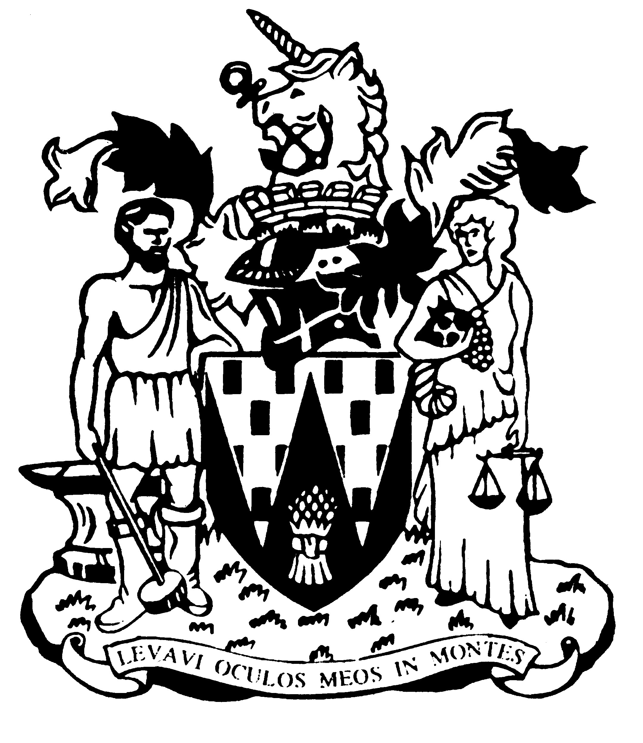

Workington Town Council

Annual Report 2021-22

Councillor Herbert Briggs
Mayor of Workington

Workington Town Council
Membership – April 2022
Name | Ward
Cllr Herbert Briggs (Town Mayor) | Harrington
Cllr Will Wilkinson (Deputy Town Mayor | St Michaels
Cllr Carole Armstrong | Salterbeck
Cllr R Briggs | Harrington
Cllr Barbara Cannon | Westfield
Cllr Beth Dixon | Northside
Cllr David Farrar | St Michaels
Cllr Sue Fryer | St John’s
Cllr Ged Glaister | St John’s
Cllr Hilary Harrington | Harrington
Cllr Michael Heaslip | St John’s
Cllr Jackie Kirkbride | Stainburn
Cllr Antony McGuckin | St John’s
Cllr Sean Melton | Westfield
Cllr Billy Miskelly | St Michaels
Cllr Patricia Poole | St John’s
Cllr Denice Rollo | Salterbeck
Cllr Blain Sansom | Moorclose
Cllr Neil Schofield | Westfield
Cllr Paul Scott | St John’s
Cllr Stephen Stoddart | Moorclose
Cllr Linda Williams | Moorclose
Cllr Ellie Wood | Salterbeck

Annual Report 2021-22
Welcome back to Workington Town Council Town Assembly, after two years of online meetings due to the pandemic lockdowns we are now able to meet up again in person.
The financial year 2021-22 saw Workington Town Council add to the councils portfolio with the purchase of an office building on Princess Street at the edge of Vulcan Park. This allows the council to offer a community room to local groups which is now home to our ‘Golden Girls’ bingo club, refugees coffee morning and socialising, and provides a home for all of our council committee meetings and the majority of our full council meetings.
This year has been very full for Workington Town Council despite the restrictions of COVID 19, our projects have included a new memorial in Vulcan Park of a wooden Soldier to commemorate Victory in Europe and Victory in Japan at the end of the second World War, continuing our collaboration with Workington Nature Partnership and, of course, our packed events calendar.
We have continued with our annual events; Remembrance Sunday which this year saw thousands of members of the public come out if support; Armed Forces Day, Easter Trail, our various Fun Days; Christmas Light switch on; Winter Wonderland; Shakespeare in the Park – ‘Comedy of Errors’ (odd socks), and many more. We also introduced a few new events; our first Fireworks display – this was supported by over five thousand people! Our first Mental Health Awareness week with our very first yarn bombing!
In 2021 we saw the very sad death of Cllr Joe Holiday, the Council’s condolences are conveyed to his family, though he would be very proud that his daughter (Cllr Patricia Poole) now stands for the council.
Catherine Gourlay, Town Clerk

An overview of the Town Council’s Accounts for the year ending 31 March 2022

The council collected £560,550 from council taxpayers in 2021-2022. Additionally it received grant income from a number of sources; Cumbria County Council provided…£6,370 for a Bee Happy Garden; £35,521 in Retrospect of Vulcan Park Projects; £10,000 for new pathways in Vulcan Park and £8,358 towards the Winter Wonderland event. Cyclife provided £6,370 for a storage container; £7,200 from National Lottery Reach Out; £21,251 from the Police & Crime Commissionaire for Safer Streets; £12,700 from the Welcome Back fund and £12,000 from the Cumbria Woodlands Trust.
Staffing levels are at 7 with three estates team members, two events officers, one finance & administration officer, an administration officer and the town clerk.
The council also continued to fund the Workington Nature Partnership in conjunction with Allerdale Borough Council, which supports one member of staff.
The council’s brief year end receipts and payments (estimated, unaudited).
Income
Precept £560,550
Grants £97,998*
Rents and fees £5,816*
Total £540,141*

Expenditure Total £620,450*
* This is an estimated, unaudited figure based on cash projections for the year end. The difference between income and expenditure was made from earmarked Reserve funds.
Full audit accounts will be available for inspection by the general public on 1 June.

A View on the Budget for 2019-20
The council has set a budget for 2022-23 based on a 10% increase for Band D council taxpayers. The council tax base for the town only increased by 0.5% in the previous year, meaning the council had to raise slightly more than anticipated.
It is anticipated that this will bring in a precepted income of £618,850. The Borough Council has now decided to completely phase out any contribution from their central government funding to the Town Council by reducing the council tax support grant to zero. This means the Town Council now shoulders the full burden of the changes made to the way that Council Tax benefits are calculated, by central Government in 2012.
The investment in Cultural Events continues in 2022-23 with the Council’s Culture Committee allocating over £159,200 to the continued development of ‘cultural activities’. This includes over £50,000 for the continued safe installation and management of the town’s Christmas lights.
The Council’s commitment to the local environment is also reflected in its allocation of £129,000 to parks, play areas, nature reserves and allotments, as well as ensuring the town continues to put on an impressive display for Cumbria in Bloom

Catherine Gourlay, Town Clerk

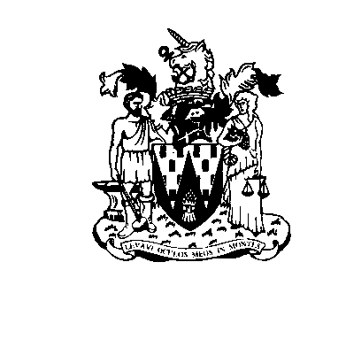
WORKINGTON TOWN COUNCIL
Town Hall, Oxford Street, Workington, Cumbria CA14 2RS
Telephone: 01900 702986
Email: office@workingtontowncouncil.gov.uk
Website: www.workingtontowncouncil.gov.uk

