
Workington Town Council
Workington Town Council Community Centre, Princess Street,
Workington, Cumbria, CA14 2QG.
Telephone: 01900 702986
Email: office@workingtontowncouncil.gov.uk
Website: www.workingtontowncouncil.gov.uk

Date of issue: Friday 24th May 2024 v2.
To Members of the Culture & Community Committee:
Cllr Ellie Wood (Chair) | Cllr Susan Martin (Vice Chair)
Cllr Beth Dixon | Cllr Paul Larkin
Cllr David Farrar | Cllr Tricia Poole
Cllr Sue Fryer | Cllr Stephen Stoddart
Cllr Allan Hodgson | Cllr Joan Wright

(Copy for information only to other members of Workington Town Council).
You are summoned to a meeting of Workington Town Council’s Culture & Community Committee on Tuesday 28th May 2024 at 6.30pm.
The meeting will be held at the Workington Town Council Community Centre, Princess Street, Workington, CA14 2QG.

Yours sincerely,
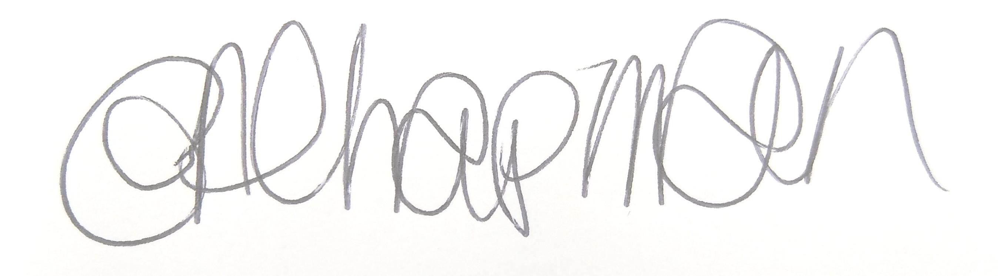

Emma Chapman
Interim Proper Officer

AGENDA
- Absences: To note any absences.

- Declarations of Interest: To receive any declarations of interest relating to matters on the agenda.

- Exclusion of Press and Public: To consider whether there are any agenda items during consideration of which the press and public should be excluded.

- Public Participation: To consider any agenda items in which public participation will be permitted.

- Minutes of previous meetings: To approve the minutes of 16th April 2024 and affirm them a true record.

- Public Questions: To consider any questions from electors, of which notice has been given in accordance with Standing Order 3w.

- Questions and Statements from Members: To consider questions and statements by members of which notice has been given.

- Motions on Notice: To consider any motions from members of which notice has been given.

- Budget:
- To note the budget monitoring report YTD.
- To approve an invoice from the Carnegie Theatre Trust for £5,000.
- To approve an invoice from the Carnegie Music Centre for £2,500.

- Events Programme 2024: To note the report and approve spend where required on the events programme 2024.

- Christmas Trees: To note the report for information.

- Previous applications for funding/commission requests: To note that the following has been approved by the Chair and Vice Chair prior to the meeting:
- Zebra Finches, funding of £500 from the Cultural Commissions – Sports budget line to assist with costs for their trip to the final.

- New funding/commission requests:
- To consider an application from Denis Devlin Films
- To consider an application from Westfield Church
- To consider an application from WADAMS

- Funding Reports
- To note the report from the Carnegie Theatre Trust for 2023-2024.
- To note the report from the Carnegie Music Centre for 2023-2024.
Carnegie Theatre Trust Annual & Financial Report has also been sent as a supporting document to support the reports.

