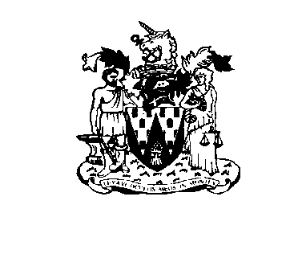
Workington Town Council
Town Hall, Oxford Street, Workington, Cumbria CA14 2RS
Telephone: 01900 702986
Email: office@workingtontowncouncil.gov.uk
Website: www.workingtontowncouncil.gov.uk

1st September 2021

To Members of Culture Committee

Cllr C Armstrong (chair) | Cllr J Kirkbride
Cllr R Briggs | Cllr S Stoddart
Cllr G Glaister | Cllr P Scott
Cllr H Harrington | Cllr P Poole
Cllr J King | Cllr L Williams

(Copy for information only to other members of Workington Town Council)

You are summoned to a meeting of Workington Town Council Culture Committee on Tuesday 7th September 2021 at 7pm.

The meeting will be held at the Workington Town Council Community Centre, Princess Street, Workington.

Yours faithfully

CGourlay

Catherine Gourlay
Town Clerk
AGENDA

1. Apologies
To receive and accept any apologies. If accepted, apologies will be considered to be for reasons approved by the Council under the terms of Local Government Act 1972, s85.

2. Declarations of Interest
To receive any declarations of interest relating to matters which appear on this agenda, but which have not been previously declared on members’ declarations of pecuniary interest and other interests.

3. Exclusion of Press and Public (Public Bodies Admission to Meetings Act 1960)
To consider whether there are any agenda items during consideration of which the press and public should be excluded.

4. Minutes of the Previous Meetings
To receive the minutes of the meeting on 13th July 2021 and affirm them as a true record.
5. Proposed Event Calendar for 2021-2022
To review and agree the event Calendar for 2021-2022. (Full list attached, all dates are subject to committee aproval)

6. Christmas Trees
To receive a brief update on the progress.

7. Memorials
To receive an update as to the status of the statue.

8. Time Capsule
To consider the suggestion of having a time capsule under one of the monuments in Vulcan’s Park.
9. Fireworks
To agree a cost for the upcoming firework event.
10. Grant Applications
To consider the following grant applications….
- Frodsham Pensioners (app attached)
- Tribe Cumbria (app attached)

