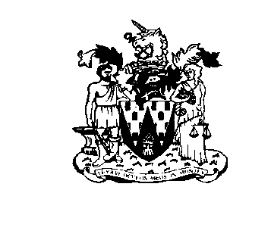
Workington Town Council
Town Hall, Oxford Street, Workington, Cumbria CA14 2RS
Telephone: 01900 702986
Email: office@workingtontowncouncil.gov.uk
Website: www.workingtontowncouncil.gov.uk

6th July 2021

To Members of Culture Committee

Cllr C Armstrong (chair) | Cllr J Kirkbride
Cllr R Briggs | Cllr S Stoddart
Cllr G Glaister | Cllr P Scott
Cllr H Harrington | Cllr P Poole
Cllr J King | Cllr L Williams

(Copy for information only to other members of Workington Town Council)

You are summoned to a meeting of Workington Town Council Culture Committee on Tuesday 13th July 2021 at 7pm.

The meeting will be held at the Workington Town Council Community Centre, Princess Street, Workington.

Yours faithfully

CGourlay

Catherine Gourlay
Town Clerk
AGENDA

1. Apologies
To receive and accept any apologies. If accepted, apologies will be considered to be for reasons approved by the Council under the terms of Local Government Act 1972, s85.

2. Declarations of Interest
To receive any declarations of interest relating to matters which appear on this agenda, but which have not been previously declared on members’ declarations of pecuniary interest and other interests.

3. Exclusion of Press and Public (Public Bodies Admission to Meetings Act 1960)
To consider whether there are any agenda items during consideration of which the press and public should be excluded.

4. Minutes of the Previous Meetings
To receive the minutes of the meeting on 1st June 2021 and affirm them as a true record.
5. Presentation by Gabi Liska
To receive a presentation by Gabi Liska from discovery stories and sharing communities

6. VE/VJ Memorial Statue Update
To receive a brief update on the project to establish a VE/VJ memorial statue.

7. Christmas
To discuss the way forward.

8. Sports Equipment
To consider requests from Harrington and Moore Close for sport equipment.
9. Grant Applications
To consider the following grant applications….
- Workington Operatic Society (app attached)

