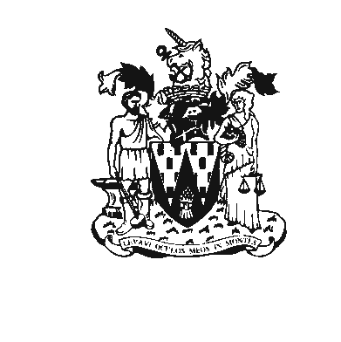
Workington Town Council
Town Hall, Oxford Street, Workington, Cumbria CA14 2RS
Telephone: 01900 702986
Email: office@workingtontowncouncil.gov.uk
Website: www.workingtontowncouncil.gov.uk

4 April 2016

To all Town Councillors

Dear Sir or Madam

ANNUAL MEETING OF WORKINGTON CIVIL PARISH
The Annual Town Meeting of Local Government Electors for the Civil Parish of Workington will be held in Christ Central Church Rooms, Central Square, Workington on Wednesday 13 April 2016. The meeting will commence at 6pm.

All electors and members of the general public are very welcome to attend.

Yours faithfully

Chris Bagshaw
Town Clerk

Agenda
- Apologies
To receive and accept any apologies for absence

2. Declarations of Interest
To receive any declarations of interest.

3. Minutes of previous meetings
To receive and agree the minutes of the Town Meeting held on 29 April 2015.
4. Annual Report
To receive the Annual Report of the Town Council

5. Town Council Accounts
To receive a statement of the Town Council’s Accounts for the year ending 31 March 2016

6. Observations on budget for 2015-16
To receive the Council’s observations on its budget and finances for 2016-17.

7 Cumbria County Council
To receive a report on the activities of Cumbria County Council in Workington.

8. Allerdale Borough Council
To receive a report on the activities of Allerdale Borough Council in Workington.

9. Issues from Electors
To consider any issues from electors in the town.

