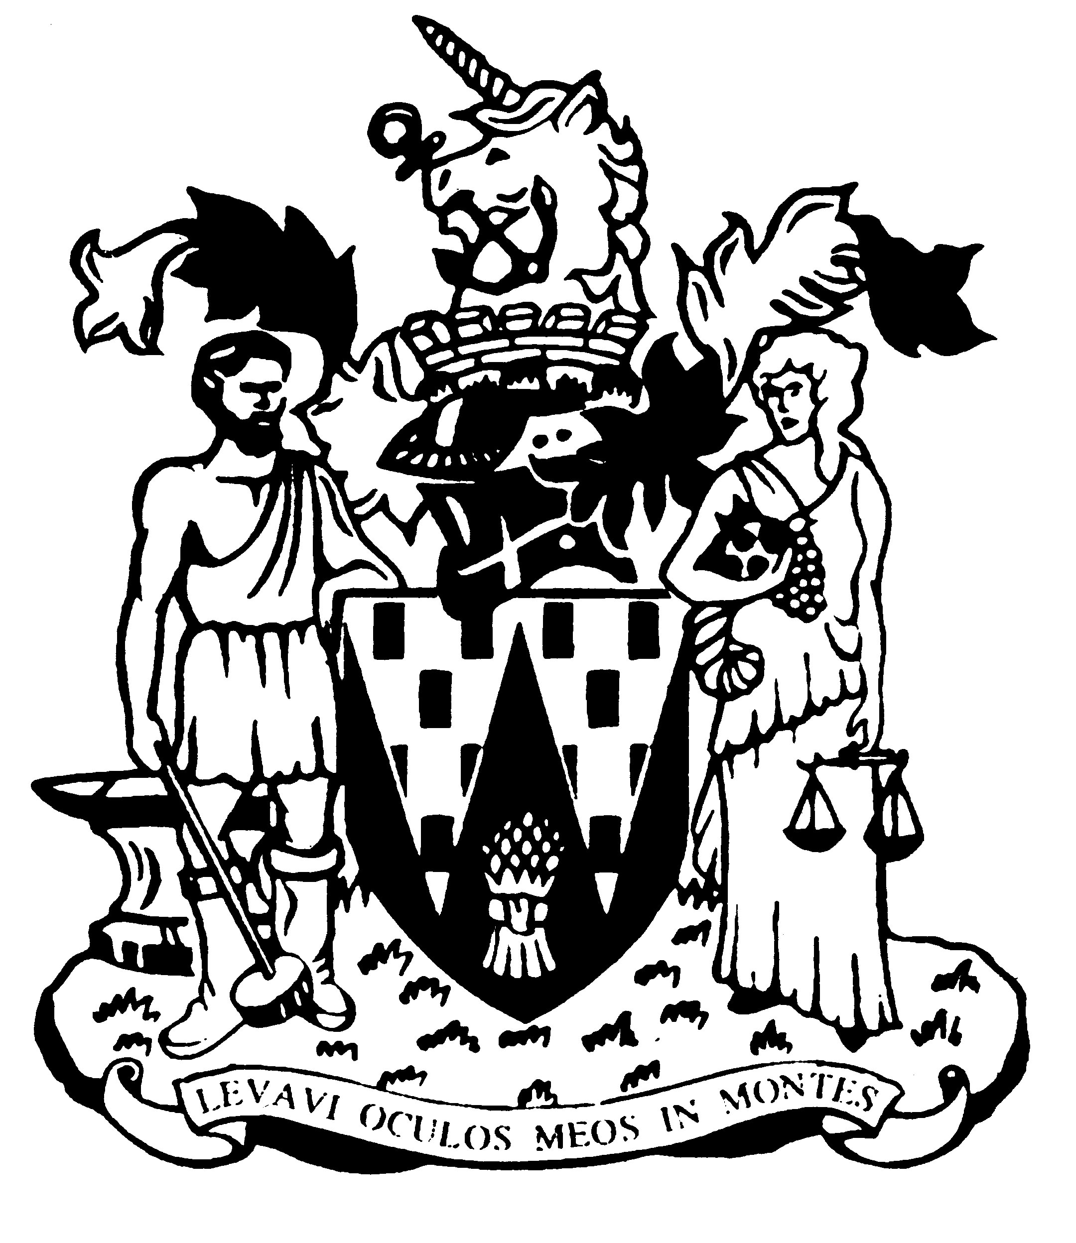

Workington Town Council

Annual Report 2023-24

Councillor Beth Dixon
Mayor of Workington

Workington Town Council
Membership – From May 2023-2024
Name | Ward
Cllr Beth Dixon (Town Mayor) | Northside
Cllr Neil Schofield (Deputy Town Mayor) | Westfield
Cllr Hilary Harrington | Harrington
Cllr Paul Larkin | Harrington
Cllr Nath Martin | Harrington
Cllr Stephen Stoddart | Moorclose
Cllr Lynda Williams | Moorclose
Cllr Joan Wright | Moorclose
Cllr Barbara Cannon | Salterbeck
Cllr Denise Rollo | Salterbeck
Cllr Ellie Wood | Salterbeck
Cllr Sue Fryer | St Johns
Cllr Michael Heaslip | St Johns
Cllr Susan Martin | St Johns
Cllr Patricia Poole | St Johns
Cllr Mike Rollo | St Johns
Cllr David Tennyson | St Johns
Cllr Mary Bainbridge | St Michaels
Cllr David Farrar | St Michaels
Cllr Allan Hodgson | St Michaels
Cllr Bernadette Jones | St Michaels
Cllr Mark Fryer | Stainburn
Cllr Jackie Kirkbride | Stainburn
Cllr Sean Melton | Westfield
Cllr Kate Schofield | Westfield

Annual Report 2023-24
The financial year 2023-2024 saw many new and previous Councillors be elected to Workington Town Council in May 2023, all with the same purpose to improve the town in which we live.

The Environment Committee have been working hard on establishing a partnership with Vulcan Park bowling club, which sees them taking over the maintenance of the green and building on behalf of the Council; this new partnership will open up new opportunities for the Club to provide public events and increase their membership and interaction with the community; plus a number of new funding avenues. They will continue to be supported by WTC Estates Team.

Budget for a new play area was secured in the Westfield ward and the Council are very excited to open this later in 2024. A great deal of work has gone into this project by Officers and Cllrs and the Council are happy to be able to provide a much needed free play space for the Westfield Ward.

The Council continues to support and develop the areas managed and maintained by Workington Nature Partnership who are dedicated to enhancing the environment in and around the town. The Bee Happy Garden in Vulcan Park is thriving and now has regular visits from a great spotted woodpecker.

The Culture & Community Committee have been busy hosting many free events throughout the town; the second ‘Reach Out’ event focussing on health and well-being was very well attended and gave the community valuable insight into self-care tips and the many services and support on offer in the Town.

Christmas Festival and Light Switch On was the best one yet with something on offer for everyone; supporting local businesses and giving new organisations a chance to advertise their services and products.

The Development Committee have been instrumental in supporting residents in their responses to local planning applications and giving feedback to the local planning authority, acting in the best interests of the community. The Committee have also been working with the local emergency response group to discuss future plans.

Finance and General Purposes have been focussing on council assets and creating an action plan to ensure these are enhanced and more available for the community.

Cllr Beth Dixon, Mayor of Workington

An overview of the Town Council’s Accounts for the year ending 31 March 2024.

The council collected £660,709.30 from council taxpayers in 2023-24.

Additionally it received grant income and funding from a number of sources, which included:
- £3,000 from the NHS Green Social Prescribing Development Fund for establishing the Sky Garden and Sensory Garden in Vulcan Park
- £8,350 from National Lottery Community Fund for the Reach Out event
- £475.99 from Cumbria Wildlife Trust towards Vulcan Park restoration works
- £1,851.34 from Cumbria Woodlands for the tree works at Annie Pit & Northside

The council’s staff consists of nine posts (eight full time and one part time):
- the Town Clerk
- the Deputy Proper Officer
- one Projects and Events Officer
- one Finance & Administration Officer
- one Administration Officer (p/t)
- four Estates Team members

The council also continued to fund the Workington Nature Partnership in conjunction with Cumberland Council, which supports two part time members of staff.

The council’s brief year end receipts and payments (unaudited).

Income
Precept | 660,709
Grants | 13,677
Dividends | 7,374
Rents and fees | 29,993
Total | 711,753
Expenditure | 769,555

These figures are unaudited. The difference between income and expenditure was made up from council reserve funds.

Full audit accounts will be available for inspection by the general public on 1 July 2024.

A View on the Budget for 2024-25

The Council unanimously agreed a budget at a meeting of the Full Council on 24th January 2024.
In some areas the council has had no choice but to add increases to the budget where previous budgets did not allow for effective, future, financial planning. The council is also experiencing the same rising costs as everyone else and has had to plan for this. The increase equates to 82p per week.
In other areas, the budget allows the Council to be ambitious with regards to the provision and maintenance of play areas and open spaces. Our aim is to provide free accessible outdoor space and equipment close to home, for everyone in the town.

The Council has budgeted for an enhancement of the Christmas lighting scheme, with development to the infrastructure, which is needed to ensure consistency plus an attractive alternative to the artificial Christmas tree that was badly damaged in the weather. The Council has worked on an alternative with the contractor which can withstand Cumbrian weather.

The budget also allows for the continuation of a popular events programme; with an additional focus on supporting local community groups and youth development within the town. The Council has introduced a number of additional ‘commissions’ budget lines, which will allow Officers to work closer with organisations and community groups to support their aims with funding, advice and guidance.

The Council will be bringing back the Workington half marathon for the first time in 41 years; this will form part of the Festival of Running event on Sun 6th August with the half marathon starting off in the picturesque Hall Park and finishing at the Reds ground where everyone can enjoy entertainment and a food festival while cheering on the runners.

The Council is committed to sourcing external funding to enhance what we can provide and to achieve the best value for money for the council tax payers of Workington.

Workington Town Council
Workington Town Council Community Centre, Princess Street,
Workington, Cumbria, CA14 2QG
Telephone: 01900 702986
Email: office@workingtontowncouncil.gov.uk
Website: www.workingtontowncouncil.gov.uk

