
Workington Town Council
Town Hall, Oxford Street, Workington, CA14 2RS
Telephone: 01900 702986
Email: office@workingtontowncouncil.gov.uk
Website: www.workingtontowncouncil.gov.uk

Date of issue: Thursday 15th May 2025
To Members of the Environment Committee:
Cllr Michael Heaslip (Chair) | Cllr Bernadette Jones (Vice Chair)
Cllr Mary Bainbridge | Cllr John Mills
Cllr Beth Dixon | Cllr Billy Miskelly
Cllr Susan Martin | Cllr Patricia Poole
Cllr Sean Melton | Cllr Mike Rollo

(Copy for information only to other members of Workington Town Council).
You are summoned to a meeting of Workington Town Council’s Environment Committee on Thursday 22nd May 2025 at 6.30pm.
The meeting will be held at the Workington Town Council Offices, Town Hall, Oxford Street, Workington, CA14 2RS.

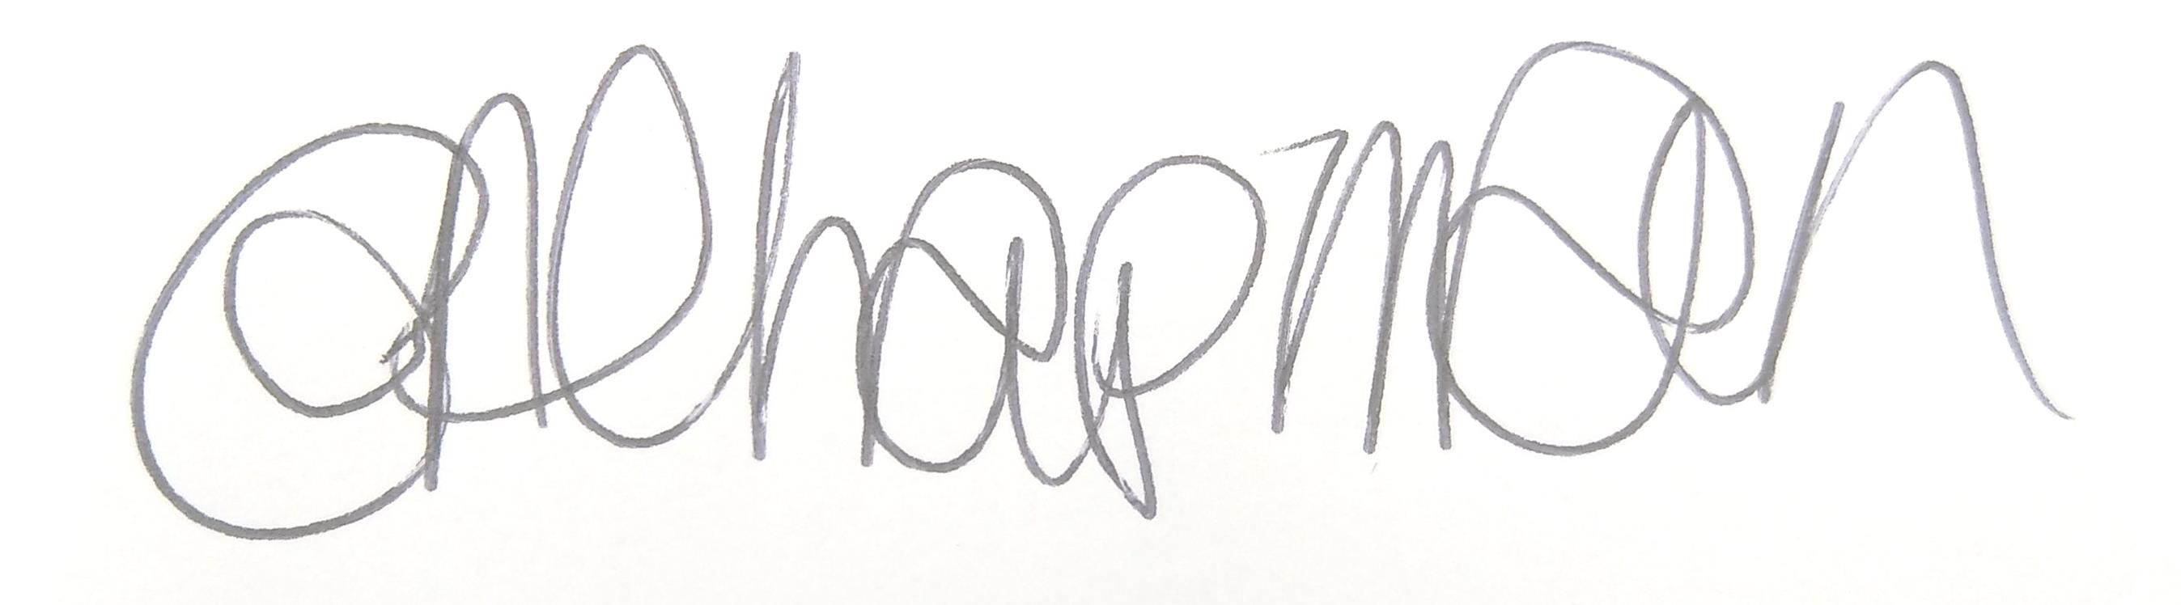

Emma Chapman
Chief Officer/RFO

AGENDA
1. Absences: To note any absences.

2. Declarations of Interest: To receive any declarations of interest relating to matters which appear on this agenda.

3. Exclusion of Press and Public: To consider whether there are any agenda items during consideration of which the press and public should be excluded.

4. Public Participation: To consider any agenda items in which public participation will be permitted.

5. Minutes of the previous meeting: To consider the minutes from the 9th April 2025 meeting and affirm them a true record.

6. Public Questions: To consider any questions from electors, of which notice has been given.

7. Questions and Statements from Members: To consider questions and statements by members of which notice has been given.

8. Motions on Notice: To consider any motions from members of which notice has been given.

9. Budget 2025-2026: To note the budget monitoring report YTD.

10. Environmental Activities: To note the report on the following for information.
a. Cumbria in Bloom
b. RHS Britain in Bloom
c. Flower bed sponsorship

11. Streetscene: To note the report on the below and make any decisions required:
a. Defibrillator at Town Hall
b. Defibrillator at Barepot
c. Workington Gateway Pocket Park update (report to follow)
d. Police Update (newsletter for information)

12. Allotments: To note the report and make any decisions required.
a. Mountain View
b. Water provision
c. Allotment plot measurements

13. Cumberland Council’s License to Grow: To note the presentation for information.

14. Estate Management: The Ranch – committee to be aware that a completed hire agreement from WJFC has been received by Officers.

15. Estate Development: To note the report on the following and make any decisions required.
a. Cast iron lampposts
b. Activity markings
c. Accessible picnic benches
d. Feenans community garden

16. Workington Nature Partnership: To note the report for information.

