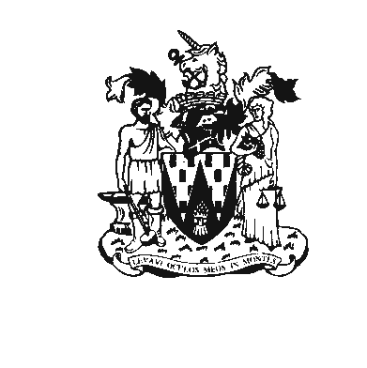
WORKINGTON TOWN COUNCIL
Workington Town Council Community Centre, Princess Street,
Workington, Cumbria CA14 2QG
Telephone: 01900 702986
Email: workingtontowncouncil@allerdale.gov.uk
Website: www.workingtontowncouncil.com

ANNUAL MEETING OF WORKINGTON CIVIL PARISH
The Annual Town Meeting of Local Government Electors for the Civil Parish of Workington will be held in Trades Hall, Brow Top, Workington on Wednesday 20th April 2022. The meeting will commence at 6.30pm.

Agenda
- Apologies
To receive and accept any apologies for absence

2. Declarations of Interest
To receive any declarations of interest.

3. Minutes of previous meetings
To receive and agree the minutes of the Town Meeting held on 27 March 2019.

4. Annual Report
To receive the Annual Report of the Town Council

5. Town Council Accounts
To receive a statement of the Town Council’s Accounts for the year ending 31 March 2022

6. Observations on budget for 2022-23
To receive the Council’s observations on its budget and finances for 2022-23.

7 Cumbria County Council
To receive a report from a Councillor for the Town elected to serve on Cumbria County Council

8. Allerdale Borough Council
To receive a report from a Councillor for the Town elected to serve on Allerdale Borough Council

9. Issues from Electors
To consider any issues from electors in the town.

