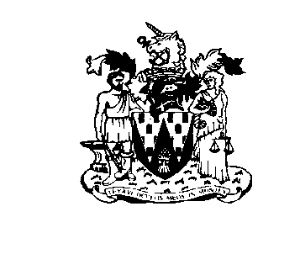
Workington Town Council
Workington Town Council Community Centre, Princess Street,
Workington, Cumbria CA14 2QG.
Telephone: 01900 702986
Email: office@workingtontowncouncil.gov.uk
Website: www.workingtontowncouncil.gov.uk

6th January 2022

To Members of Culture Committee:

Cllr C Armstrong (chair) | Cllr S Stoddart
Cllr R Briggs | Cllr P Scott
Cllr G Glaister | Cllr L Williams
Cllr H Harrington
Cllr J King

(Copy for information only to other members of Workington Town Council)

You are summoned to a meeting of Workington Town Council Culture Committee on Wednesday 12th January 2022 at 7pm.

The meeting will be held at the Workington Town Council Community Centre, Princess Street, Workington.

Yours faithfully

CGourlay

Catherine Gourlay
Town Clerk
AGENDA

1. Apologies
To receive and accept any apologies. If accepted, apologies will be considered to be for reasons approved by the Council under the terms of Local Government Act 1972, s85.

2. Declarations of Interest
To receive any declarations of interest relating to matters which appear on this agenda, but which have not been previously declared on members’ declarations of pecuniary interest and other interests.

3. Exclusion of Press and Public (Public Bodies Admission to Meetings Act 1960)
To consider whether there are any agenda items during consideration of which the press and public should be excluded.

4. Minutes of the Previous Meeting
To receive the minutes of the meeting on 9th November 2021 and affirm them as a true record.

5. Feedback on events 2021
To receive an update on events that took place in 2021.

6. Events 2022-2023
- Events calendar and budget for 2022-2023
- To consider adding a small fee to the fireworks tickets to help cover costs (officer suggestion of £1).
- To consider the layout of the Christmas Festival 2022 and if it should be kept the same as 2021, including the introduction of additional lighting outside Bensons for Beds to allow for a more spectacular switch on.
- To consider stall / vendor charges for 2022-2023.
- To receive an update on procurement for events for 2022-2023.

7. Grants
- Workington Town Band

