Workington Town Council
Trustee of the Borough of Workington
Workington Town Council Community Centre, Princess Street,
Workington, Cumbria, CA14 2QG.
Telephone: 01900 702986
Email: office@workingtontowncouncil.gov.uk
Website: www.workingtontowncouncil.gov.uk

WORKINGTON TOWN COUNCIL
PLAY POLICY

Purpose of the policy
This play policy has been developed for the provision, maintenance and development of play areas owned and managed by Workington Town Council.
The United Nations convention of the rights of a child states:
- Play is the highest expression of human development in childhood
- Play is a vital component of growing up.
- Play is how children develop skills, physical, social and intellectual.
- Play provides children with opportunities to test out themselves and others.
- Play gives children opportunities to practice and prepare for the outdoor world.
- Children should have full opportunity for play and recreation and society and public authorities shall endeavour to promote the enjoyment of this right.

Policy Statements
- To provide where possible, conventional play areas, environmental play areas and community play activities to provide every opportunity to play.

Conventional – Traditional play areas with the five modes of play.

Environmental – play area featuring natural elements that feel integrated with the outdoor landscape.

Community – provide children the opportunity to practice and hone key skills including social, emotional, cognitive and physical.

- Ensure the play area facilities owned by WTC comply with all the appropriate British Standards to minimise the risk of accidents and help provide a safer environment for children to enjoy play.

- To ensure all children within the parish of Workington have a play area within a reasonable distance for a child to walk.

- The Council will consider provision of specialist play facilities for the town of Workington as a whole, where possible. And will consider taking responsibility for play facilities of all kinds where they meet our standards, and the owner wishes to transfer them to us.

- Consideration will be made in ensuring safer routes to play areas are available when considering locations.

- Monitor, assess, and review design and installation of the play area. Investigate and take note of any new research into the safety standards regarding play areas. Accidents in play areas arise from many causes including but not limited to:
- Inappropriate design and layout.
- Incorrectly installed equipment.
- Inadequately installed equipment.
- Lack of age and ability related equipment.
- Lack of supervision
- Aggressive and dangerous use of equipment.
- Misuse of equipment
- Unsuitable clothing worn.

- Carry out routine weekly inspections as well as a fully documented certified 12 month inspection completed by an independent inspector. Sites should be visually inspected regularly by the nominated person or persons for superficial defects and faults to equipment in addition to general cleanliness and removal of dangerous objects. The documented inspections shall be carried out in accordance with current legislation by trained inspectors.

- Monitor safety by keeping a central record of all reported injuries and serious incidents on council owned play areas. This information can be taken into account when updating and installing new play equipment.

- Carefully consider the implications for access to, and experience of play opportunities when dealing with planning applications relating to new developments. Environmental play is of the most valuable and natural form of play and children should be given the chance to challenge and manipulate their environment.

- Encourage play schemes and provide where possible experiences of the natural environment by creating areas of wildland, nature trails etc. this would include informal play areas like trim trails or partnership projects contributed to by the council such as forest schools.

- Provide opportunities for informal play including informal sporting play in our municipal parks and open spaces: (formal sports pitch provision is subject of a separate policy).

- Consultation with the general public in particular school children and parents to take into account their needs when replacing, updating or installing new play equipment or areas. Conventional play areas should aim to have all 5 modes of play available, namely swing, rocker, rotor, agility and slide (examples of which can be found at the bottom of the policy). Parents and schools can be a valuable source of information when considering this equipment.

- Formulate a forward plan and update and amend as necessary and as any new legislation or standards dictate. This will take account of all information gained from consultation with the local community and any accidents/incidents reported.

- Endeavour to introduce more play provision for children with disabilities as standard. Disabled children should have access to a play environment which allows them the same opportunity for recreation and play as able-bodied children. They should be given the opportunity to mix with able bodied children and where possible have the use of suitable play equipment.

- Assist in making parents aware of their responsibility to children and seek their help to provide a safe environment in which they can play. This will be achieved by the provision of literature and signage.

- Design and build play parks that are more environmentally friendly by using more recycled materials for equipment and working with suppliers who are actively looking to reduce their carbon footprint.

- Designate all play areas as dog free zones to provide an area that is free from dog faeces as is practicable under part IV of the Environmental Protection act 1990 or other appropriate powers.

- Maintain a site register for the play area which contains:
- A copy of this policy
- A site plan
- Full equipment details
- Documentation of the ownership of the site
- Inspection, maintenance and any future development plans.
- Details of reported accidents and serious incidents.
Summary
The play policy is designed to take account of all statutory requirements in addition to this the Council’s commitment to provide safe formal play areas and environmental play opportunities within the confines of its budget facilities.
Workington Town Council understands and acknowledges the need to:
- Consult and liaise with parents, children and schools before purchasing any new play equipment thereby ensuring the type of equipment will be enjoyed by and put to its maximum potential use.
- Educate parents/guardians to be aware of their responsibility in play areas.
- Provide more play equipment for disabled children and bear this in mind when considering the purchase of new play equipment.
- Install signs in prominent positions stating that play areas are dog free zones.
- Update or replace old and defective equipment.
- Recognise the expected life of existing equipment and create a replacement plan.
- Maintain a site register and ensure it is kept up to date.
- Ensure inspections are carried out as set out in policy statement no.4.
- The council will take responsibility of play areas of all kinds provided by others where they meet our standards and the owner wants to transfer them to us.

Examples of Equipment - 5 Modes of Play

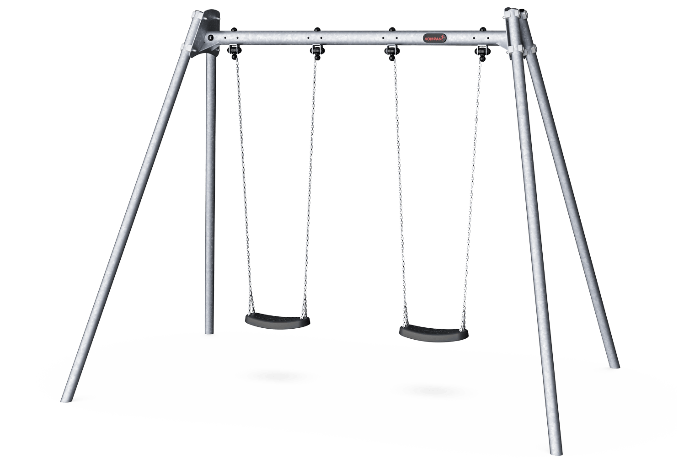
Swing
Agility
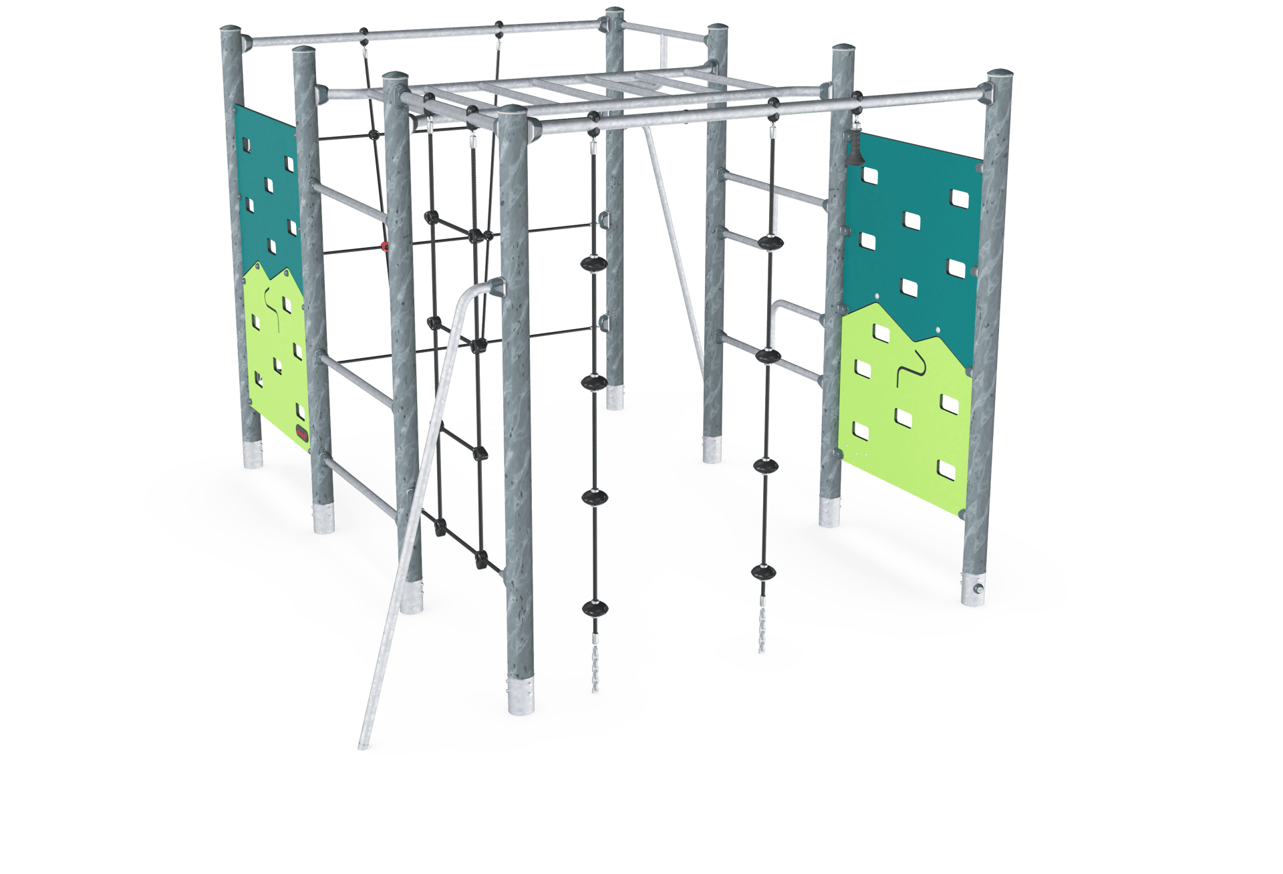

Rocker

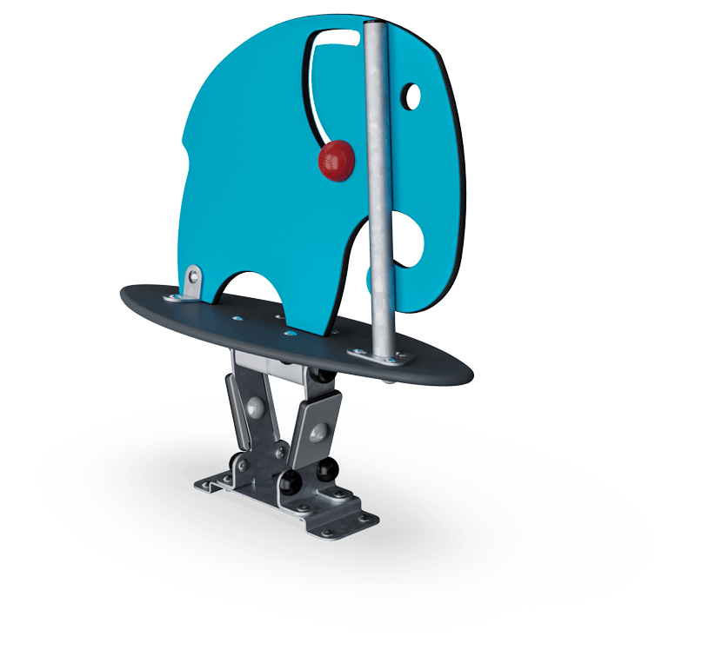
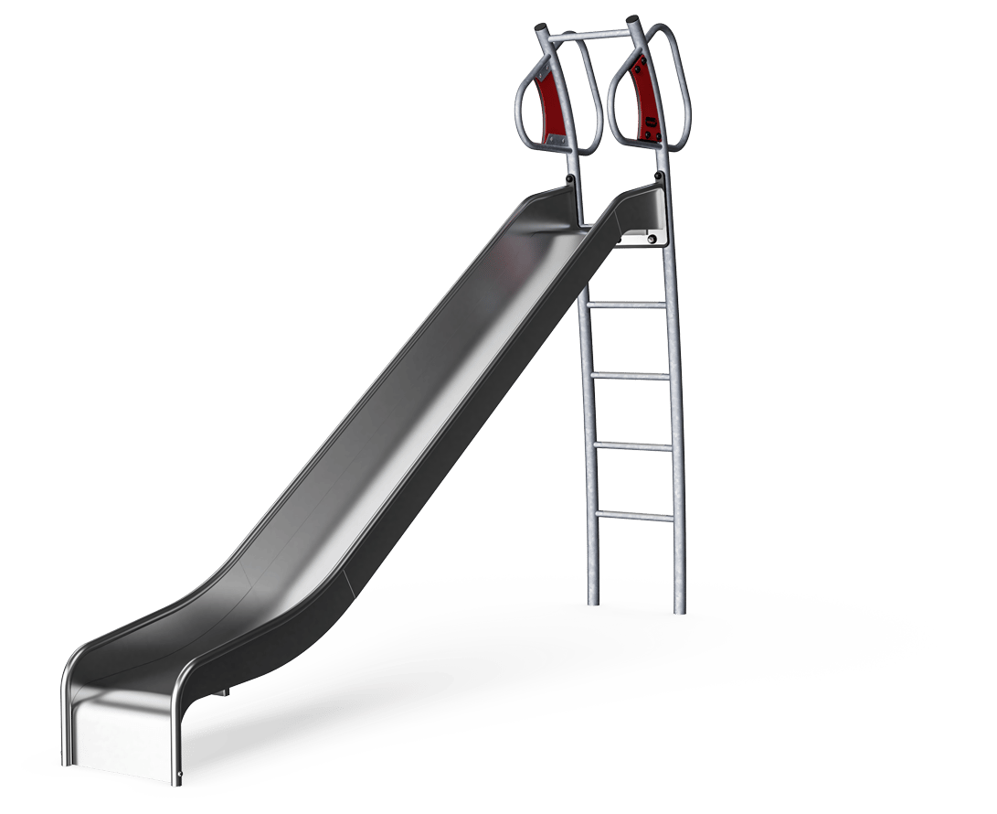
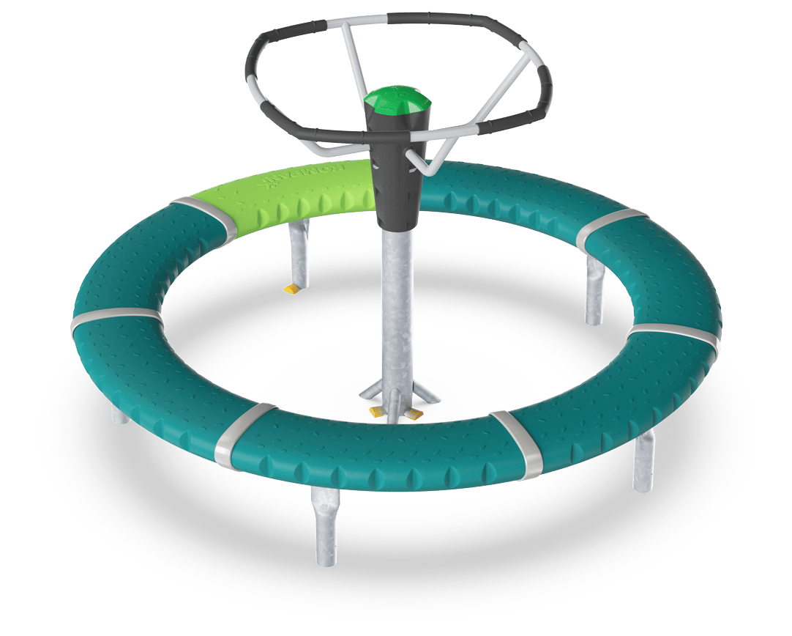
Slide
Rotor

