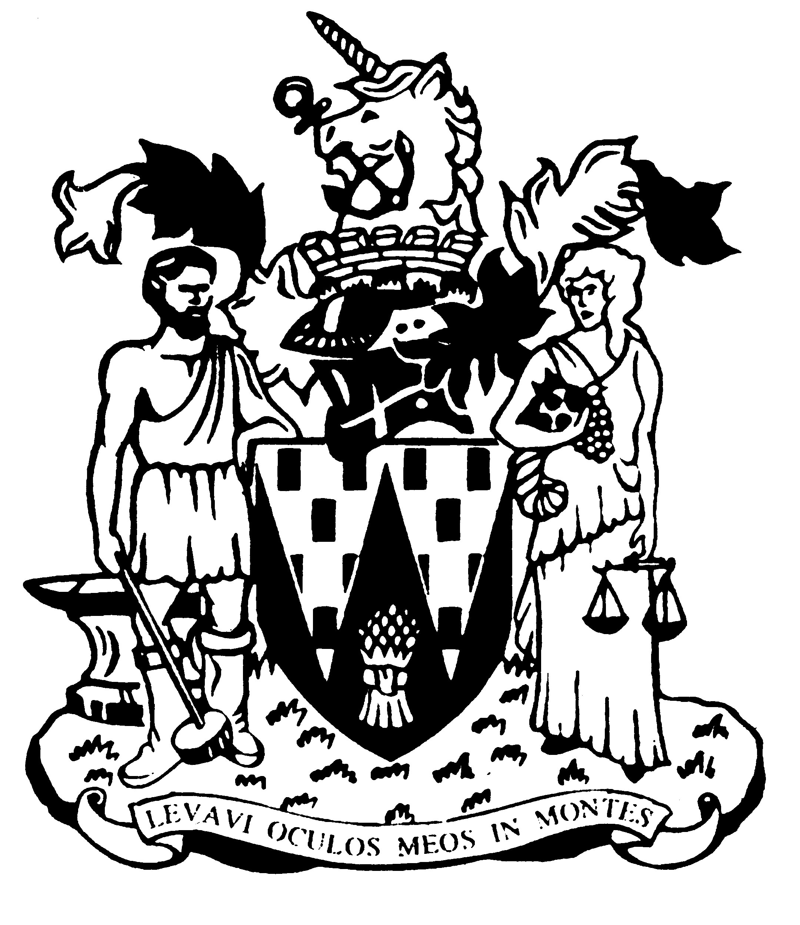

Workington Town Council

Annual Report 2016-17

Councillor Joan Wright
Mayor of Workington

Workington Town Council
Membership 2016-17
Name | Ward
Cllr Joan Wright (Town Mayor) | Moorclose
Cllr Ann Bales (Deputy Town Mayor) | Moorclose
Cllr Carole Armstrong | Salterbeck
Cllr Mary Bainbridge | St Michaels
Cllr Lillian Baldry | Salterbeck
Cllr Peter Bales | Moorclose
Cllr Barbara Cannon | Moss Bay
Cllr David Cashman | St Michael’s
Cllr Beth Dixon | Northside
Cllr Mark Fryer | Stainburn
Cllr Konrad Hansen | St John’s
Cllr Hilary Harrington | Harrington
Cllr Michael Heaslip | St John’s
Cllr Christine Johanssen | Moorclose
Cllr Peter McHarry | Ellerbeck
Cllr Frank Johnston | Stainburn
Cllr Joe Holliday | St John’s
Cllr Andrew Lawson | St Michael’s
Cllr Antony McGuckin | St Joseph’s
Cllr Billy Miskelly | St Michael’s
Cllr Vonnie Morgan | Harrington
Cllr Jim Osborn | Harrington
Cllr Bill Reville | Salterbeck
Cllr Denis Robertson | Moorclose
Cllr Denise Rollo | Salterbeck
Cllr Mike Rollo | Moss Bay
Cllr Kate Schofield | St Michael’s
Cllr Neil Schofield | St Michael’s
Cllr Stephen Stoddart | Moorclose
Cllr Tricia Wardley | Iredale

Annual Report
This year the Town Council consolidated its position as a shaper of the local community. 2016 saw the return of play facilities to Moorclose Green after an absence of nearly 20 years. The installation was made possible by a partnership with Allerdale Borough Council as landowner, setting an example of local authorities working together to deliver services. A partnership with Impact Housing also delivered revamped play facilities on Wordsworth View, by the Oval Centre in Salterbeck, adding to the play area on Walker Road, restored the previous year, as valuable assets for families in the town.
The council delivered some memorable events – Paint the Town Red returned to fill the streets with entertainment, Workington Go! established a strong lead for leisure opportunities for young people – street art, archery, snorkelling, canoeing and climbing were just some of the activities on offer. The Christmas lights switch-on produced another great day of festivities in the town centre, and the Family Fun Days continued to be very popular, with summer events in Harrington, Moorclose and Vulcans Park adding to Christmas, Easter and Halloween themed craft events.
The Workington Nature Partnership continues to deliver very effective results, with its officer now running popular ‘Forest School’ sessions with local primary schools. The Town Council funds half the costs of the partnership and oversees its service delivery through a steering group. The Town Council put additional funding into Harrington Reservoir Nature Reserve, which with its vibrant friends group, is beginning to reassert itself as a popular recreational destination in South Workington.
Cumbria in Bloom plays an important role in focussing the town’s summer floral displays. This year we were rewarded for our efforts with first prize in the large town category – a considerable achievement in the current climate of challenges to local government funding. The award is for the whole town, reflecting not just the stunning mangers on Washington Street but the town’s vibrant volunteer culture which demonstrates the town’s cultural depth.
Chris Bagshaw, Town Clerk
An overview of the Town Council’s Accounts for the year ending 31 March 2017
The council collected £384,439 from council taxpayers in 2016-17. Additionally it received £22,831 as a Council Tax Support Grant, a payment from central government ‘passported’ through Allerdale Borough Council to compensate for changes to the way the council tax is calculated.
It continued to expand its staffing levels, with an Assistant Town Clerk, Events Assistant and an Estate Team Leader, bringing the total complement up to 6.8 FTE.
The council has continued to support a number of the town’s third sector and voluntary organisations over the year, including West Cumbria Trades Hall, Citizen’s Advice Bureau, Workington Lifeboat, Cumbria Bloodbikes, Christmas in Company, South Workington Youth Partnership, Cumbria Youth Alliance and community centres in Northside and High Harrington.
The council also continued to fund the Workington Nature Partnership in conjunction with Allerdale Borough Council.
The council’s brief year end receipts and payments (estimated, unaudited).
Income
Precept £384,439
Council Tax Support Grant £22,381
Rents £17,254
Other income* £61,940
Total £486,014

Expenditure Total £629,864
The difference between income and expenditure was made from Reserve funds, which had been identified as running higher than required.
Full audit accounts will be available for inspection by the general public on 1 June.

A View on the Budget for 2017-18
The council has set a budget for 2017-18 based on a 12% increase for Band D council taxpayers. It is anticipated that this will bring in a precepted income of £439,030. The Borough Council has once more decided to pass on the reduction in their central government funding to the Town Council by reducing the council tax support grant to £14,921. It is assumed this figure will decline to zero in 2018, leaving the town council to bear the burden alone of the government’s changes in 2013 to the way the council tax base is calculated.
The main purpose for the rise in precept is to cover the council’s ambitious plans to take over the control of the remaining parks and play areas in the town from Allerdale Borough Council. The largest of these is Vulcans Park and the town council has begun setting money aside for the repairs, renewals, development and revenue funding that such a responsibility will bring. Alongside the running of the park, the council has resolved to employ an apprentice to assist the estates team, bringing much needed investment in local skills.
The council agreed to continue funding vital third sector organisations in the town – CAB and Trades Hall – and added the town’s lifeboat, Carnegie Theatre and Helena Thompson Museum to its list of core organisations. Delivering new facilities for young people, continuing to invest in the refurbishment of the allotment estate and promoting Workington as a vibrant and exciting place to live, work, visit and invest are also reflected in the council’s funded aims. Environmental improvement work to the town’s back lanes will continue to be paid for from the reserve balances accumulated for this purpose. The rear lane on Frostoms Road from 23 to 77 has been completed this month and other projects will be brought forward to use this funding in this financial year.
The town council is planning an exciting programme of events in the coming year, including theatre and opera performances in the parks, live music and performance in the town centre, fun days and sports events for families and teenagers.

Chris Bagshaw, Town Clerk

WORKINGTON TOWN COUNCIL
Town Hall, Oxford Street, Workington, Cumbria CA14 2RS
Telephone: 01900 702986
Email: office@workingtontowncouncil.gov.uk
Website: www.workingtontowncouncil.gov.uk

