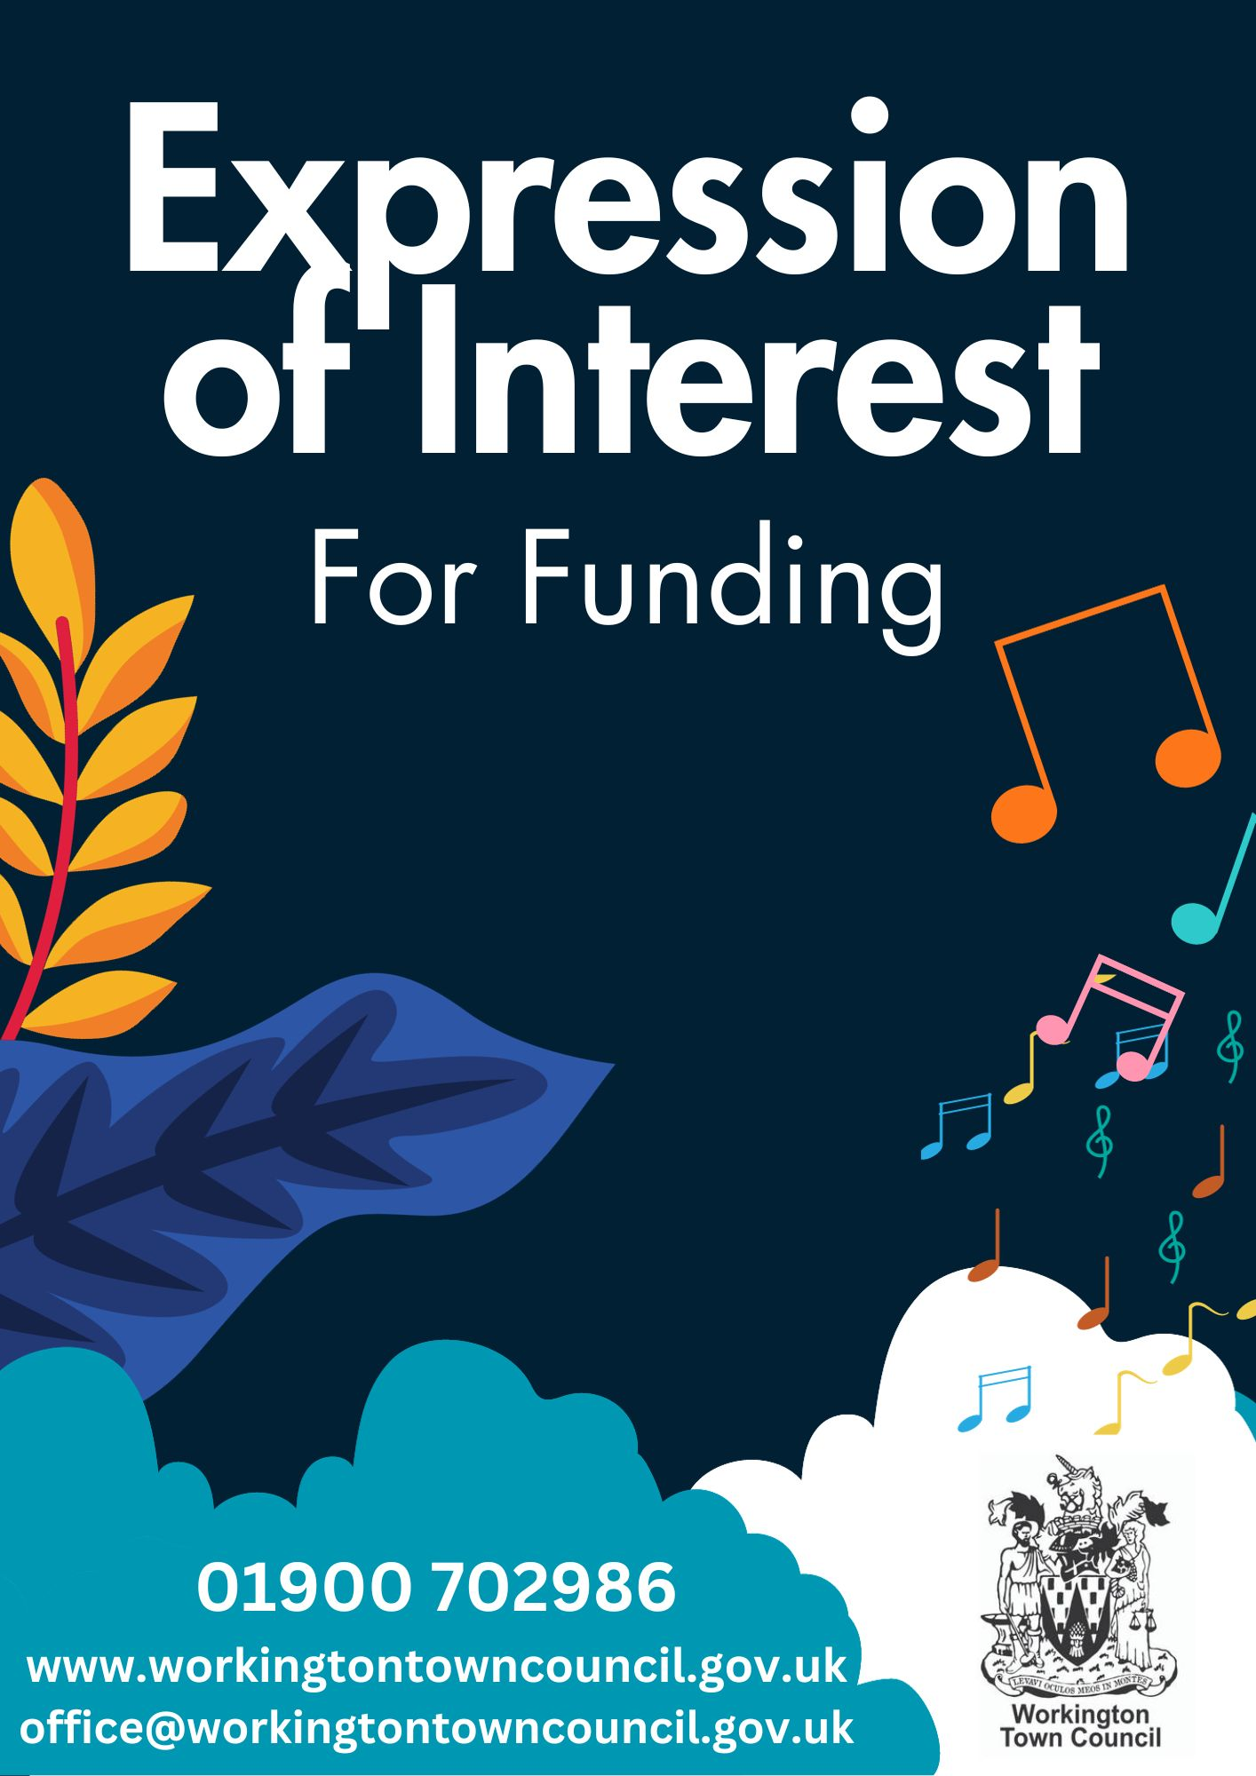

About this form

This form should be used to submit an expression of interest for funding from Workington Town Council.
Committee meetings take place every two months, so it will depend on when your form is submitted as to when it will be reviewed by the relevant committee.

Once we have received your form and reviewed the information, our Officers will be in touch to discuss your proposal in more detail.

Please use this form and e-mail the completed version to office@workingtontowncouncil.gov.uk, with the subject line ‘Expression of Interest for Funding’.

If you would prefer, you can complete this form using our Google forms template (you will need a google account to access the form). A link to the form can be found here www.workingtontowncouncil.gov.uk/grantsandfunding

The form is made up of three sections and asks you to provide information about your organisation(s) and the project for which you are seeking funding.

Section 1 - requires some basic contact information so that we can get in touch with you about your expression of interest.

Section 2 – this is where you should provide information on your organisation, and any other partner organisations involved in the project.

Please note that if you’re applying for funding as a consortium of multiple organisations, one organisation should submit an expression of interest as the lead applicant; including details of partner organisations where requested.

Section 3 - in this section we ask you to give a brief description of the project for which you are seeking funding and why you consider it to be of benefit to the wider community.

Please do not exceed the word limits for each question

Section 1 – Contact information

Applicant contact name
Enter text.

Applicant contact e-mail
Enter text.

Applicant contact phone number
Enter text.

Lead organisation address
Enter text.

Section 2 – Your organisation(s)

Please provide the name of your lead organisation and any partner organisations. Please provide registered company and/or charity numbers where applicable.
Enter text.

Please state the aims and objectives of your lead organisation. Please provide a mission statement where available. (max. 150 words per organisation)
Enter text.

Please provide a full breakdown of the lead organisation’s annual income and expenditure.
This can be provided as a separate document.
Enter text.

Please use this space to provide examples of recent activity by your organisation(s) that have benefited the people of Workington. (max. 150 words)
Enter text.

Do you have a constitution?
Yes
No

Section 3 – Your proposal

Please provide a summary of your proposal. Please include details of your plans, how they will be achieved and your objectives / anticipated outcomes. (max. 500 words)
Enter text.

Please explain the challenge(s) your proposal seeks to address. Please provide detail of how this challenge affects the areas reached by your project. (max. 200 words)
Enter text.

How many participants do you expect to reach during the course of funding?
Enter text.

Please state the amount of funding you wish to apply for, providing a full breakdown of how the funding will be spent.
Committees are happy for no specific amount to be entered here. We just ask for a full understanding of your service/project and the costs you will incur. Committees will then discuss and decide how much funding they can support you with.
Enter text.

Have you approached other funding sources? If so, please list them and the amount you have applied for.
Enter text.

Have you previously had funding from Workington Town Council? If so, when was this and what was the funding spent on?
Enter text.

Do you confirm that any funding received from Workington Town Council will be used for events/activities and services within the parish of Workington?
Enter text.

Thank you for expressing an interest in receiving funding from Workington Town Council. One of our Officers will be in touch shortly to discuss your proposal in more detail.
In the meantime, if you have any questions, please do not hesitate to contact us.
office@workingtontowncouncil.gov.uk
01900 702986
www.workingtontowncouncil.gov.uk
Facebook @workingtontowncouncil
Twitter @workingtontco
Instagram @visitworkington

