
Workington Town Council
Town Hall, Oxford Street, Workington, CA14 2RS
Telephone: 01900 702986
Email: office@workingtontowncouncil.gov.uk
Website: www.workingtontowncouncil.gov.uk

Date of issue: Wednesday 2nd July 2025
To Members of the Environment Committee:
Cllr Michael Heaslip (Chair) | Cllr Bernadette Jones (Vice Chair)
Cllr Mary Bainbridge | Cllr John Mills
Cllr Beth Dixon | Cllr Billy Miskelly
Cllr Susan Martin | Cllr Patricia Poole
Cllr Sean Melton | Cllr Mike Rollo

(Copy for information only to other members of Workington Town Council).
You are summoned to a meeting of Workington Town Council’s Environment Committee on Thursday 10th July 2025 at 6.30pm.
The meeting will be held at the Workington Town Council Offices, Town Hall, Oxford Street, Workington, CA14 2RS.

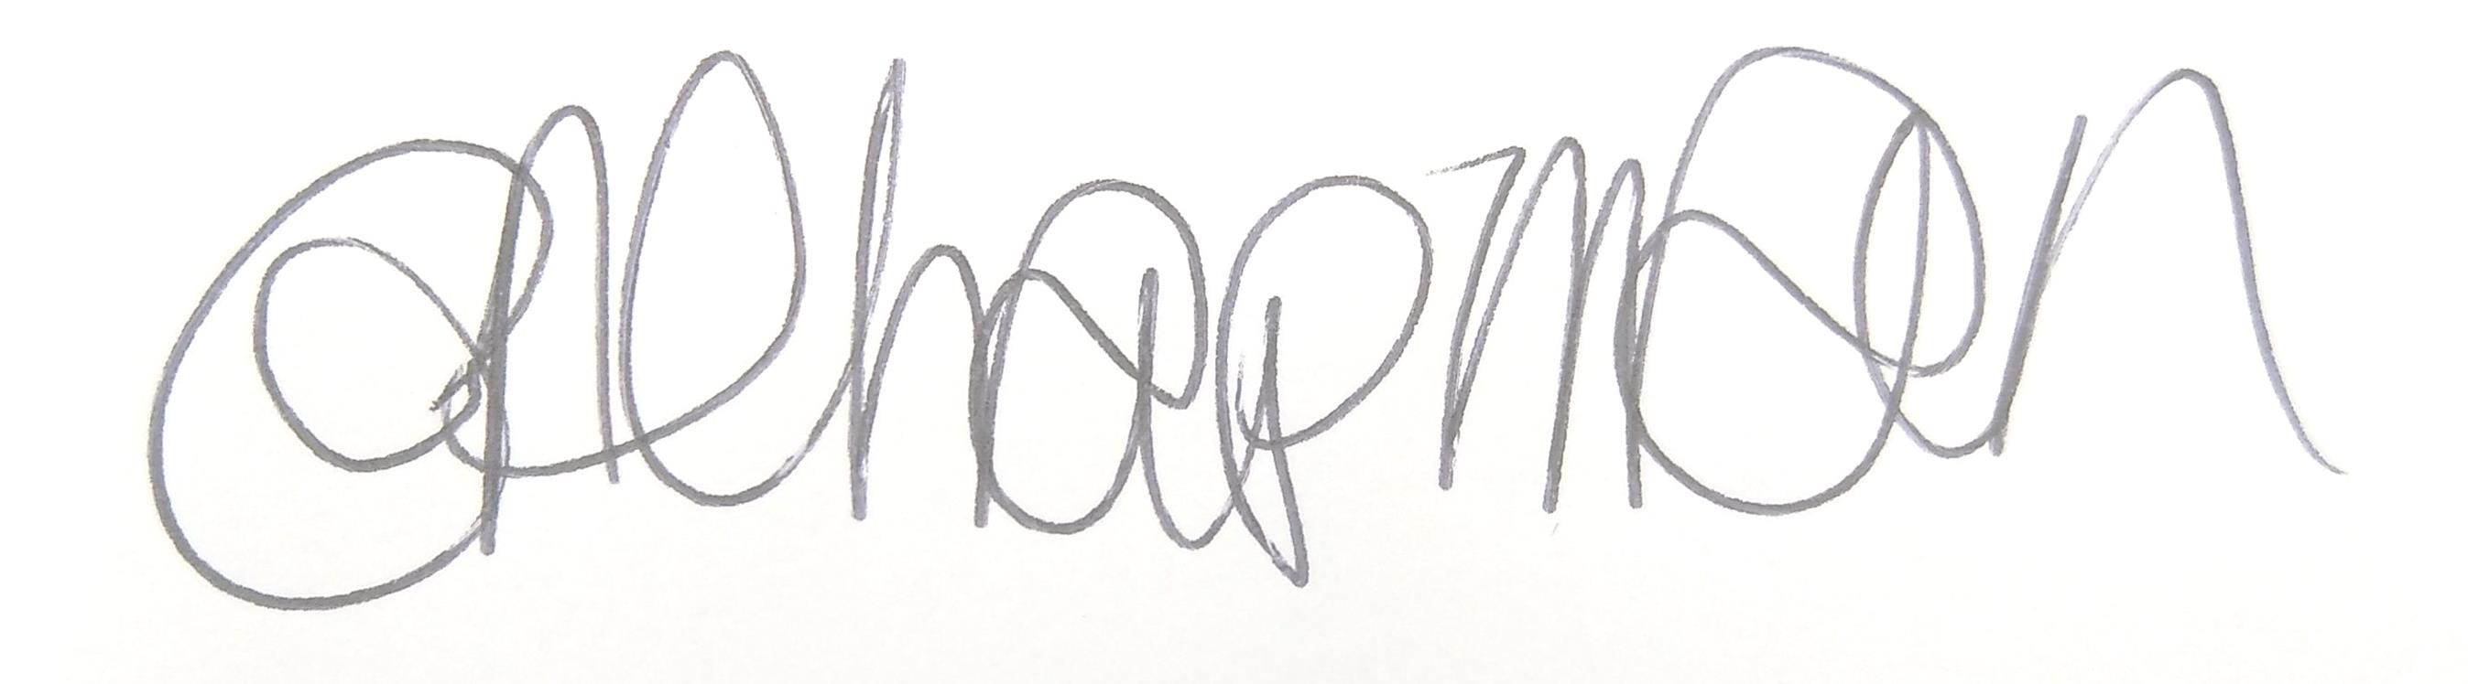

Emma Chapman
Chief Officer/RFO

AGENDA
1. Absences: To note any absences.

2. Declarations of Interest: To receive any declarations of interest relating to matters which appear on this agenda.

3. Exclusion of Press and Public: To consider whether there are any agenda items during consideration of which the press and public should be excluded.

4. Public Representation: To consider whether there are any agenda items in which public representation will be permitted.

5. Minutes of the previous meeting: To consider the minutes from the 22nd May 2025 meeting and affirm them a true record.

6. Public Questions: To consider any questions from electors, of which notice has been given in accordance with standing orders.

7. Questions and Statements from Members: To consider questions and statements by members of which notice has been given in accordance with standing orders.

8. Motions on Notice: To consider any motions from members of which notice has been given in accordance with standing orders.
a. Motion from Cllr Hodgson
b. Motions from Cllr Stoddart

9. Budget 2025-2026: To note the budget monitoring report YTD.

10. Environmental Activities: To note dates for judging are as follows:
a. Cumbria in Bloom – Wednesday 16th July
b. RHS Britain in Bloom – Tuesday 12th August

11. Streetscene: To note the reports on the below and make any decisions required:
a. Workington defibrillators
b. Workington Gateway Pocket Park

c. Draft Defibrillator policy
d. Police Update (presentation for information)

12. Vulcan Park: To consider the report and make any decisions required.

13. Play Areas: To consider the report and make any decisions required.

14. Allotments Policy: To consider an amendment to the current policy.

15. Estate Development: To note the report on the following and make any decisions required.
a. Green Hub
b. Location of new disabled access benches accessible picnic benches
c. Tennis Courts
d. Land Acquisitions

16. Workington Nature Partnership: To note the report for information.

